*Materials Needed* —

* Ruler, pencil, & paper

*Objectives* —

An Introduction to Parallax

*— OR —*

*Just How Far Away Is That Star, Anyway?*

* Understand the nature of parallax and the source of this effect in observational astronomy.
* Observe how parallax changes with distance and apply this to measuring the relative distances of stars.
* Introduce the concept of the astronomical distance ladder, of which parallax distances are the first rung, and which allows to estimate distances to the far corners of the observable universe.

*Introduction* —Parallax is a geometrical effect that can be used to obtain a direct measurement of the distance to an object. A driver and her passenger, for example, may fall prey to this effect when arguing about a car’s speed. If the car uses a needle–type speedometer, where the needle is mounted slightly in front of its dial scale, the two are likely not to make the same reading when checking how fast the car is moving. The driver may see that the car is going 60 mph (i.e., the needle appears projected against the 60 mark on the dial), but the passenger may think that the car is moving at some other speed. This is due to the gap between needle and dial and to the fact that the driver and passenger observe the gage from different distances and viewing angles.

But parallax isn’t just a source of arguments: as this activity will show, it’s a powerful tool for measuring distances, something that

Fig. 1.— Tycho Brahe, one of the great observational astronomers of any era, and the most famous brawling astronomer ever. He lost his nose in a duel at age 20, and wore a fake for the rest of his life. *The portrait is by an unknown artist and reproduced with permission from the Wikipedia Commons.*

is incredibly difficult in astronomy. The first recorded instance of the use of parallax in astronomy came in 1577, when Tycho Brahe (see Figure 1) used it to find the distance to a comet. While we now have other techniques for measuring the distances to objects in the Solar System, parallax remains the only way to directly measure the distance to objects outside of our Solar System—particularly to stars. In this activity you will first build up your intuition about what parallax is and how it depends on distance, and then apply this to observations of stars1.

Part I: What is parallax?

1. Predict what your finger would appear to do relative to the background if you were to put it about 3–4 inches from your face and close one eye at a time while watching it.
2. Now go ahead and do this. Was your prediction correct? Comment.
3. Predict how the apparent motion of your finger would change if you moved your finger twice as far from your face?
4. Now do this. Was your prediction correct? Comment.
5. If you had amazing Stretch Armstrong arms, is there a limit to how far you could move your finger and still see it appear to move? If so, how far away do you think that would be? (To get an idea of this distance, have someone far away from you hold up their finger.)
6. What is it about our eyes that allows us to see this apparent motion?

Part II: What happens when your finger is a star?

1. The point labeled E in Figure 2 represents the Earth in its orbit in January. Use a ruler and draw a line from the Earth to the background stars going through Star A. Mark the Earth–Star A–Sun angle. This is called the *parallax*.
2. Describe what you think will happen to that angle if we were to do what we just did but for Star B.
3. Test your prediction by using Figure 2. Comment on your results. Were you correct?
4. Now, find where the Earth will be in six months.

The imaginary line that runs from the Earth’s position in January through the Sun to the Earth’s position in July, is our baseline. In general, this is the separation between the positions from which two measurements are made, and it is perpendicular to the direction to the object whose distance we are measuring.

Repeat question 7 using star A at this new position in its orbit. Draw on Figure 3 below where Star A will appear to be in January and then six months later.

1. Extend our observations over a number of years. How will Star A appear to move against the background stars?
2. How about star B over the same number of years compared to the motion of Star A?
3. The apparent motion of stars as seen from Earth relative to a background of more distant, fixed stars, is known as *stellar parallax*. Now think back to your experiment in part I. What is it about the Earth that corresponds to blinking your eyes?

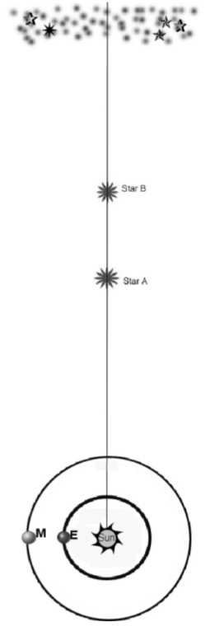

Fig. 2.— View of Earth, Sun, two nearby stars, and a bunch of distant stars.

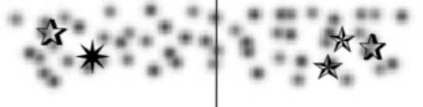

Fig. 3.— Where would Star A appear relative to the background in January? Six months later?

1. Below is a set of parallax observations of different stars. Rank them from nearest to farthest. Explain your logic. Nearest Farthest.

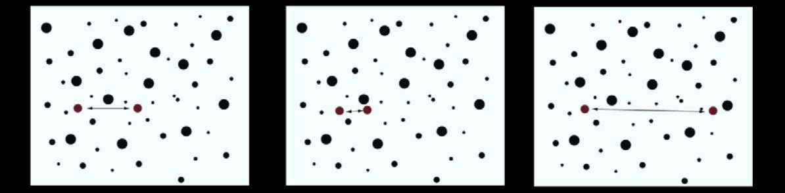

Part III: What happens when your eyes are far, far apart?

1. We used Figure 2 to examine the parallax angle of Stars A and B. Let’s focus on Star A for now. What would happen to the parallax angle of A if we measured it from Mars instead of Earth?
2. Consider this conversation between two students:

Student 1: I think that if we measured the parallax of a star from Mars, the angle would be larger than if we measured it from Earth because Mars has a much larger orbit. This would cause the star to move an angle comparable to that of its orbit.

Student 2: If we measured the parallax from Mars, the angle would have to be smaller because Mars is farther from the Sun so the star would also have to be farther away from Mars.

With whom do you agree? Explain.

1. Now test your predictions as well as those of Student 1 and Student 2. Do this by repeating what we did in question 7, but use the orbit of Mars in Figure 2. What are your results? Why would a longer baseline be desirable?

Bonus:

1. Why might the argument between passenger and driver be worse in a British car?
2. What other techniques can we use to measure the distances to objects in the Solar System? Why won’t these work to measure the distance to even the nearest star?
3. Successful *stellar* parallax measurements are a fairly recent accomplishment. Why?

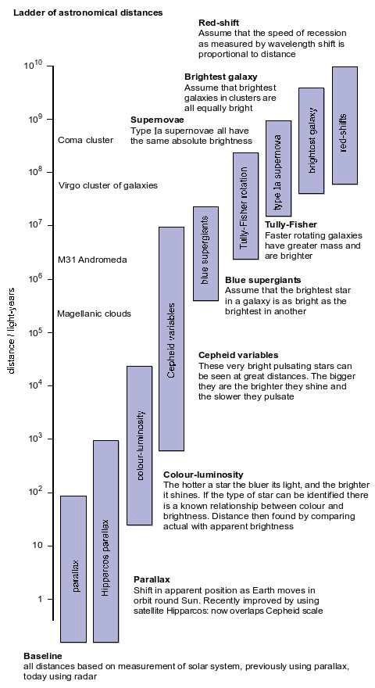Part IV: What happens when your finger is REALLY far away?

Even the nearest star, Alpha Centauri, is more than 200,000 times further away than the diameter of the Earth’s orbit. This means that the shift in angle we observe in Alpha Centauri is less than 1 second of arc, or less than the thickness of a hair seen across a large rooma. It was not until the mid–19th century that astronomers were able to measure such small parallaxes. In recent years, good parallax measurements, previously limited to a few thousand stars, have been extended to greater distances by the scientific satellite Hipparcos. But ultimately, even from space, parallax distances can only be measured for a relatively small number of objects that are relatively nearby.

A full discussion of how we estimate distances to objects for which we cannot obtain parallax measurements is beyond the scope of this activity. But it is important to note that ultimately all of the different techniques we use link back to parallax measurements, which is why parallax is often referred to as the first step in the astronomical distance ladder (see Figure 4).

*For a suite of activities about the expand- ing universe and the distance ladder, see* [*http://www.iop.org/activity/education/.*](http://www.iop.org/activity/education/) *This text and Figure 4 are adapted from “The ladder of astronomical distances” (TAP 704–8) handout available there.*

aYou may have heard astronomers use parsecs when discussing distances. A parsec is the dis- tance at which a star would shift by 1 second of arc to and fro as the Earth moves round its orbit, and it’s equal to roughly 3 light–years.

Fig. 4.— *From the Institute of Physics,* [*http://www.iop.org/.*](http://www.iop.org/)