Lung Capacity Lab NAME:

Human lung capacity – or how much air can fit in your lungs – can be measured in several ways. One way is by using a piece of laboratory equipment called a spirometer. Lung capacity can also be measured using a balloon. The data you obtain may not be as accurate as that obtained using a spirometer though.

Several different lung volume measurements can be made:

- Vital capacity is the largest possible amount of air that can be exhaled after drawing a deep breath

- Expiratory reserve is the amount of air that remains in the lungs after exhaling normally (it is the extra air that can be breathed out)

- Tidal volume is the amount of air taken in or expelled during normal breathing

Part A: Vital Capacity

- Stretch the balloon several times
- Take as deep a breath as possible. Then exhale all the air you can into the balloon and pinch the balloon closed to prevent air from escaping
- Measure and record the diameter of the balloon in centimeters in your Data Table below. You will need a helper to hold the two metric rulers to measure it.

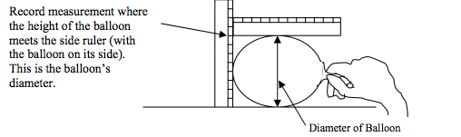

- Deflate the balloon and do two more trials. Record the diameters of the balloon in your Data Table.
- Using Graph A on the LAST PAGE of this worksheet, find the volume that goes with the diameter.

Trial Number | Diameter of Balloon in CENTIMETERS | Volume of Balloon (see graph)
1
2
3
Average

Part B: Expiratory Reserve

- Inhale normally then exhale normally. Then exhale the REST of the air still in your lungs into the balloon
- Measure and record the diameter of the balloon in centimeters in your Data Table below. You will need a helper to hold the two metric rulers to measure it.
- Deflate the balloon and do two more trials. Record the diameters of the balloon in your Data Table.
- Using Graph A on the LAST PAGE of this worksheet, find the volume that goes with the diameter.

Trial Number | Diameter of Balloon in CENTIMETERS | Volume of Balloon (see graph)
1
2
3
Average

Part C: Tidal Volume

- Take in a normal breath. Exhale into the balloon only as much air as you would normally exhale. DO NOT force your breathing.
- Measure and record the diameter of the balloon in centimeters in your Data Table below. You will need a helper to hold the two metric rulers to measure it.
- Deflate the balloon and do two more trials. Record the diameters of the balloon in your Data Table.
- Using Graph A on the LAST PAGE of this worksheet, find the volume that goes with the diameter.

Trial Number | Diameter of Balloon in CENTIMETERS | Volume of Balloon (see graph)
1
2
3
Average

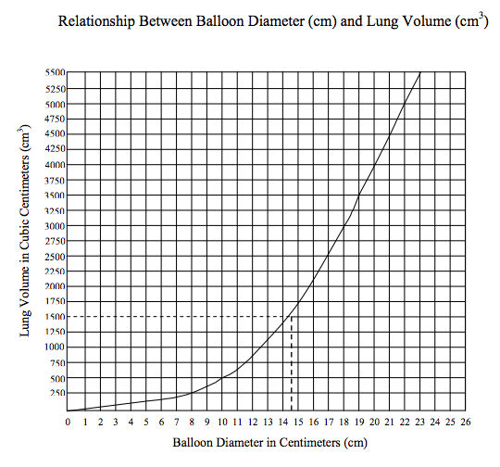
ANALYSIS QUESTIONS: Written on separate in complete sentences. Staple to this paper.

- Compare the volumes of the balloons in part A, B and C. Which has the greatest volume: Vital capacity, expiratory volume, or tidal volume? Explain why.

- Compare your results to someone else in the room. How are their results different compared to yours? Explain why.

- Why do you think different people have different lung volumes? Name two variables.

- What were some of the difficulties you had in doing this lab? What were your mistakes?
(i.e. outside variables)
- Predict the effect of smoking on lung capacity. Which type of lung capacity might it affect? Explain why you think this.

