AFJROTC
NATIONAL AWARDS REFERENCE GUIDE

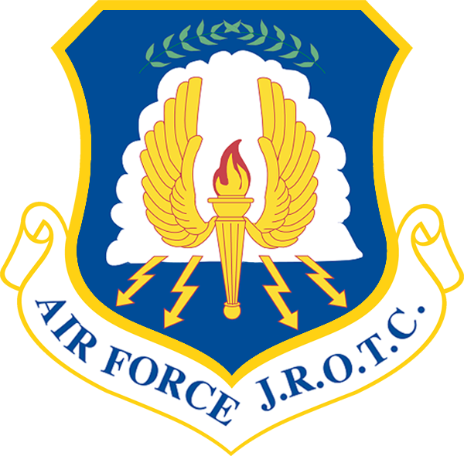

The AFJROTC Awards and Decorations Program recognize the achievements of AFJROTC cadets and fosters increased morale and espirit de corps. The following awards will be presented tonight and are recognized nationally.

Awards are in order of precedence.

AIR FORCE ASSOCIATION AWARD-
This award consists of a medal and a ribbon that is presented annually to the outstanding second-year cadet (in a 3- year program) or third-year cadet (in a 4- year program)

The award recipient must possess/meet the following personal characteristics and eligibility criteria:
- Positive attitude (toward AFJROTC and school).
- Outstanding personal appearance (uniform and grooming).
- Display personal attributes such as initiative, judgment, and self-confidence. Courteous demeanor (promptness, obedience, and respect for customs).

DAEDALIAN AWARD-
The Order of Daedalians is a fraternity of commissioned pilots from all military services. This award is offered to encourage the development of patriotism, love of country, and self-sacrifice in cadets and to interest them in a military career.
This annual award recognizes one outstanding third-year cadet that meets the following criteria:
- Demonstrate understanding and appreciation of patriotism, love of country, and service to the nation
- Indicate the potential and desire to pursue a military career
- Rank in the top 10% of their AFJROTC class
- Rank in the top 20% of their school class

AMERICAN LEGION SCHOLASTIC AWARD-
This award is presented annually to one second-year or third-year cadet (in a 3 year program) or a third-year or fourth-year (in a 4 year program) based on the cadet’s overall scholastic achievements. Each cadet must:
- Rank in the top 10% of the high school class
- Rank in the top 25% of their AFJROTC class
- Demonstrate leadership qualities
- Actively participate in student activities

AMERICAN LEGION GENERAL MILITARY EXCELLENCE AWARD-
This award is annually presented to one second- year or third- year based on the cadet’s general military excellence. Each cadet must:
- Rank in the top 25% of their AFJROTC class
- Demonstrate outstanding qualities in military leadership, discipline, character, and citizenship

DAUGHTERS OF THE AMERICAN REVOLUTION AWARD-
This award is presented annually to one third year or fourth year cadet that meets the following criteria:
- Rank in the top 25% of their AFJROTC class
- Rank in the top 25% of their high school class
- Demonstrate qualities of dependability and good character
- Demonstrate adherence to military discipline
- Possess leadership ability and fundamental and patriotic understanding of the importance of JROTC training

AMERICAN VETERANS AWARD-
Presented annually to one qualified cadet that possesses individual characteristics contributing to leadership such as:
- A positive attitude toward AFJROTC programs and service in the air force
- Personal appearance (wearing of the uniform, posture, and grooming, but not physical characteristics per se)
- Personal attributes (initiative, dependability, judgement, and self-confidence)
- Officer potential (capacity for responsibility, adaptability, and maintenance of high personal standards)
- Obtained a grade of “A” (or the numerical equivalent) in their AS class
- Be in good scholastic standing in all classes at the time of selection and at the time of presentation

RESERVE OFFICERS ASSOCIATION AWARD-
This award is presented annually for military and academic achievement to an outstanding third year cadet. The recipient must possess individual characteristics contributing to leadership such as:
- Positive attitude toward the AS curriculum
- Outstanding personal appearance (wear of the uniform, posture, and grooming)
- Attributes of initiative, judgement, and self-confidence
- Courtesy (promptness, obedience, and respect)
- Growth potential (capacity for responsibility, high productivity, adaptability to change)
- Demonstrate the highest personal, ethical standards, and strong positive convictions
- Rank in the top 10% of their AS class

MILITARY ORDERS OF WORLD WARS AWARD-
This award is presented annually to an outstanding cadet who has committed to continue the aerospace science program the following school year. Selection is based on outstanding accomplishment or service to the AFJROTC unit.

MILITARY OFFICERS ASSOCIATION AWARD-
This award is presented annually to an outstanding second-year cadet who shows exceptional potential for military leadership. Each cadet must:
- Be a member of the junior class
- Be in good academic standing
- Be of high moral character
- Show a high order of loyalty to the unit, school, and country
- Show exceptional potential for military leadership

VETERANS OF FOREIGN WARS AWARD-
This award is presented annually to an outstanding second or third year cadet who is actively engaged in the AFJROTC program and who possesses individual characteristics contributing to leadership. Each cadet must:
- Have a positive attitude toward AFJROTC
- Have outstanding military bearing and conduct
- Possess strong positive personal attributes (courtesy, dependability, punctuality, respect, and cooperation)
- Demonstrate patriotism (being a member of the color guard or drill team) and actively promote Americanism
- Demonstrate leadership potential
- Attain grade of “B” in AFJROTC with an overall average grade of “C” in all subjects for the previous semester
- Be active in student activities
- Not have been previous recipients of this award

NATIONAL SOJOURNERS AWARD-
This award is presented annually recognizing an outstanding first or second year cadet who contributed the most to encourage and demonstrate Americanism within the corps of cadets and on campus. Each cadet must:
- Be in the top 25% of their academic class
- Encourage and demonstrate ideals of Americanism
- Demonstrate potential for outstanding leadership
- Not have previously received the award

SONS OF THE AMERICAN REVOLUTION AWARD-
This award recognizes an outstanding second year cadet in a 3- year program or a third year in a 4- year program who is enrolled in the AFJROTC program. The recipient must exhibit a high degree of leadership, military bearing, and all-around excellence in the AS studies and not have previously received the award. Each cadet must:
- Be currently enrolled in the AFJROTC program
- Be in the top 10% of their AFJROTC class
- Be in the top 25%of their overall class

SCOTTISH RITE, AMERICANISM AWARD-
This award annually recognizes an outstanding second year or third year cadet. Each cadet must:
- Contribute the most to encourage Americanism by participation in Co-Curricular activities or community projects
- Demonstrate academic excellence by being in the top 25% of class
- Demonstrate the qualities of dependability, good character, self-discipline, good citizenship and patriotism
- Not yet have been previous recipients of this award

MILITARY ORDER OF THE PURPLE HEART AWARD-
This award annually recognizes an outstanding second year or third year cadet who is enrolled in the AFJROTC program and demonstrates leadership ability. Each cadet must:
- Have a positive attitude toward AFJROTC and country
- Hold a leadership position in the cadet corps
- Be active in school and community affairs
- Attain a grade of “B” or better in all subjects for the previous semester
- Not have been a previous recipient of this award

AIR FORCE SERGEANT ASSOCIATION AWARD-
This award recognizes an outstanding second or third year cadet. The recipient must demonstrate outstanding qualities in military leadership, discipline, character, and citizenship. Each cadet must:
- Be in the top 25% of the AFJROTC class
- Demonstrate outstanding qualities in military leadership, discipline, character, and citizenship
- Not have a previous recipient of this award

SONS OF THE UNION VETERANS OF THE CIVIL WAR AWARD-
This award recognizes one deserving cadet annually, may be first, second, third, or fourth year cadet. The recipient must display a high degree of patriotism and have demonstrated a high degree of academic excellence and leadership ability.

TUSKEGEE AIRMEN AWARD-
This award is presented annually to two cadets. Cadets may be first, second, or third years. And must meet the following criteria:
- Attain a grade of “B” or better in their AS class
- Be in good academic standing
- Actively participate in cadet corps activities
- Participate in at least 50% of all unit service programs

THE RETIRED ENLISTED ASSOCIATION AWARD-
Awarded annually for exceptional leadership to the most outstanding AFJROTC cadet while serving an enlisted rank. The selected enlisted cadet must have shown outstanding leadership throughout the course of the school year.

CELEBRATE FREEDOM FOUNDATION AWARD-
Awarded annually for outstanding performance in academics and cadets corps activities as a first or second year JROTC cadet.

NATIONAL SOCIETY UNITED STATES DAUGHTERS 1812 AWARD-
Awarded annually for academic excellence, leadership, military discipline, dependability, patriotism and upright character in speech and habits.

AIR COMMANDO ASSOCIATION AWARD-
Awarded annually for completing a one page essay based on a historical AF Special Operations Mission possessing the thirteen critical attributes of success: integrity, self-motivation, intelligence, self-discipline, perseverance, adaptability, maturity, judgement, selflessness, leadership, skilled, physical fitness and family strength.

