The Effect of Height on Lung Capacity

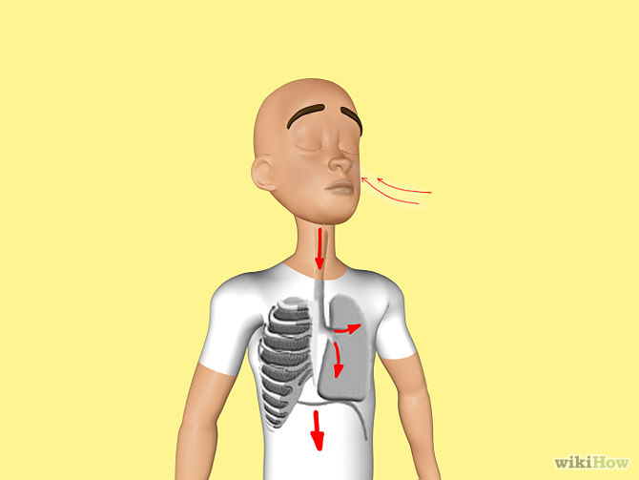

Introduction:

Lung capacity is how much air can fit into your lungs in one breath. The air we breathe contains oxygen and other gases. Oxygen bonds to hemoglobin in our blood and goes to every cell in our body.

We use oxygen (O₂) to burn sugar and get energy to live. In other words, we take in oxygen to use in the chemical reaction called cellular respiration where glucose is broken down in the mitochondria of every cell and cellular energy (ATP) is released. Here is the reaction that takes place.

C₆H₁₂O₆ (sugar) + 6O₂ -------------------> 6CO₂ + 6H₂O + ~38 ATP (energy)

What's so great about ATP? Every time you move a muscle, think, breathe, replicate your DNA, every time your heart beats - you use ATP to do this work!

Objective:

To determine the effect of height on lung capacity

Background Information:

Several different lung volume measurements can be made:

1. Vital capacity is the largest possible amount of air that can be exhaled after drawing a deep breath

2. Expiratory reserve is the amount of air that remains in the lungs after exhaling normally (it is the extra air that can be breathed out)

3. Tidal volume is the amount of air taken in or expelled during normal breathing

Hypothesis:

Procedure:
Examine your materials and brainstorm with your team. Ask yourselves, “How could I use these materials to find the volume of my lungs?”

Make a sketch of your proposed device here:

Write your procedure here:

Get your idea approved with your Science teacher. _______________________

Start building, observing, and measuring!

Data:
Lung Volume of Students of Different Heights

Height of Student  (inches) | Trial 1  Lung Capacity(cm³) | Trial 2  Lung Capacity (cm³) | Average  Lung Capacity (cm³)

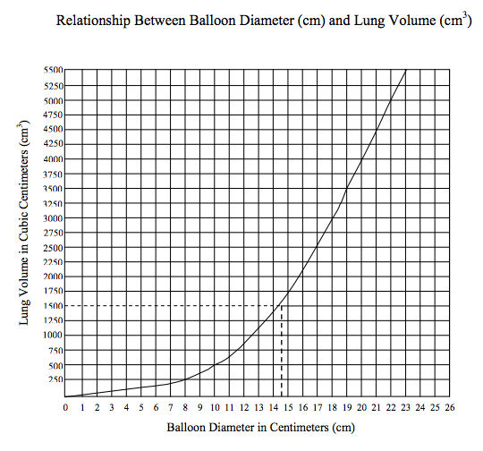
Use your data to construct a graph.
Include a properly formatted title and label each axis with the correct variable and units.
Lung Volume of Students of Different Heights

Analysis: (answer on separate paper; use complete sentences)

1. Identify the independent and dependent variables in the lab.
2. What type of lung capacity did you measure? Explain.
3. Did you create a line graph or a scatter plot? Explain how you know this. What does it look like?
4. Based upon your results, is there a relationship between height and lung capacity? How do you know this? Did you prove your hypothesis? (Refer to your graph!)
5. What is an outside variable that may have affected your results? Explain how you think it may affect lung capacity and why you think this.
6. Suggest another way that you could test lung capacity. What would you use and how would you measure lung volume?
7. Predict the effect of smoking on lung capacity. Which type(s) of lung capacity might it affect? Explain why you think this.

